The Instituto de Negocios e Innovación Times.

President Trump divorces Melania. Claims to have had sexual relationships with Elon Musk multiple times.
President Trump announced yesterday that he is divorcing Melania. In a press conference he claimed having done sex with the multimillionaire businessperson Elon Musk.

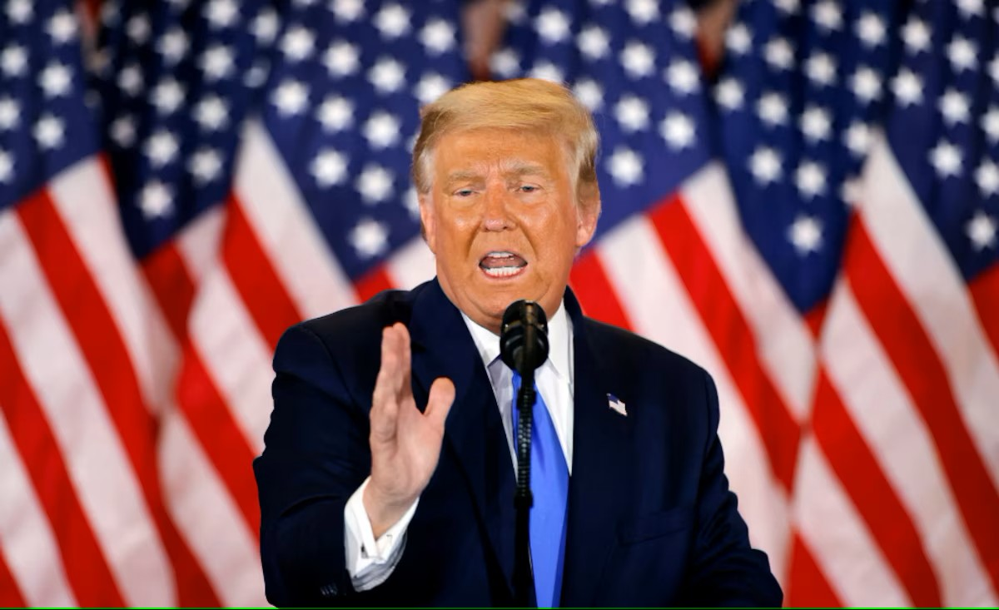
Donald Trump. Yesterday, during a big event in Washington D.C. He explained how he cheated on Melania… Not going to lie, too much information.
The Instituto de Negocios e Innovación Times.


J. Orlando González
Reporting from Palos Verdes. March 12, 2025.

Yesterday, shockingly a shocking new shocked the school shootings nation, President Donald Trump announced that he was officially divorcing Melania Trump after a 20-year relationship during a press conference in Washington D.C. In the same conference he explained that he had a crush in the multimillionaire businessperson Elon Musk, he also explained that he had done sex with Musk multiple times, even referring to him as “too tight be straight” and “a hungry boy” Which was freakily shocking (again) for the assistants, not including Melania, who claims to be already used to Trump’s homosexual tendencies.
After the press conference, Musk declared that he also had a crush on President Trump, and he did not discard the possibility of marrying him. Now, Elon Musk, I mean, Elon Trump, has the chance of become the first LGBT+ First Lady of the United States, replacing Melania who seems to be happier than ever, enjoying a relaxing vacation in Las Bahamas, at the end of the day, she only wanted a Birkin, not to become the First Lady for a man she didn’t vote for.
This love story, full of political implications, proves once again how no matter if you are the president of a nation, a businessman or a student in INEI, it’s never late to find the true love, and that all of republican homophobic “straight” men are just a bunch of closeted faggots.

“Make America Great Gay Again.”
-President Donald Trump.

Breaking News: A mythical pet eater discovered in Veracruz.
A serial killer of pets was finally found, but for the surprise of the Police the individual behind the murders was not what the police waited for.

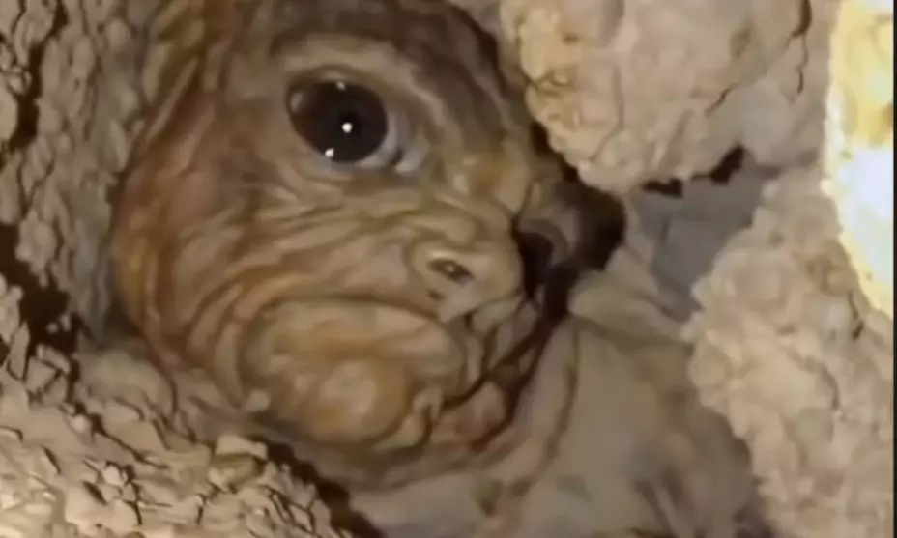
The “Chaneque Veracruzano,” recorded by a police officer in Veracruz. This is a 100% real image, not a fake one. To be honest, it looks like someone’s foreskin.
The Instituto de Negocios e Innovación Times.


Ruth Beneth Guerrero
Reporting from Guasave. March 12, 2025.
Veracruz. The serial killer of pets was finally found, but for the surprise of the police, the individual behind the murders was not who they were waiting for, it resulted be a mythical “Chaneque Veracruzano.” The creature tried to escape between a hole, but it got stuck inside, that is when an officer took the images that can be seen upside.
The Police arrived at the place of the facts after a women report how the creature was trying to eat her dog. And now with a new analysis of past testimonies the story matches. Now the authorities are in a discussion about what they will do with the “Chaneque.”
All this makes a debate between people that think the “Chaneque” is conscious of his actions and deserves a punishment, and others that think the “Chaneque” was only following his natural instincts and that we do not understand him.

Worldwide Impact: Catastrophic and Fatal Virus Outbreak.
A new virus outbreak has emerged, and the "ideal dad virus" is attacking and spreading all around the world.

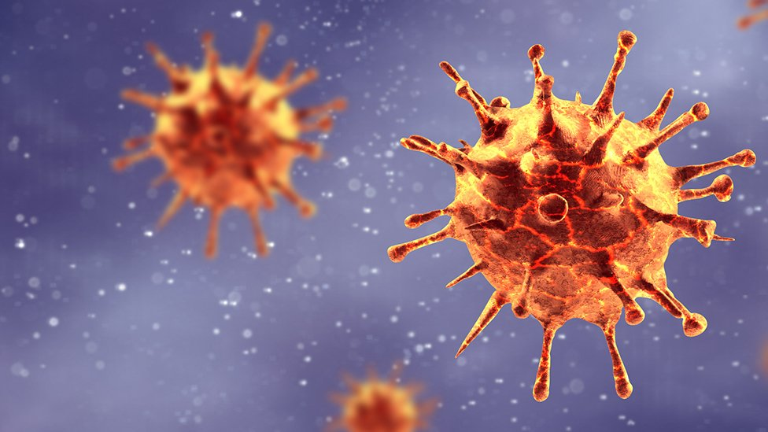
“According to testimonies, the "ideal dad virus" started to spread when an agonizing grandpa used his last breath to beat up his wife for the last time.” Explained our journalist, Rogelio.
The Instituto de Negocios e Innovación Times.


R. Alejandro Jiménez
Reporting from Guasave. March 12, 2025.

According to testimonies, the "ideal dad virus" started to spread when an agonizing grandpa used his last breath to beat up his wife for the last time. That is when (in the middle of the beating) a drop of sweat landed in his son's mouth (loving father of 31,416 kids. A pie of kids). Sixty-nine hours after the wife beating, this loving dad started to suffer the symptoms of the "ideal dad virus".
The symptoms the dad and other infected suffered beating their wife and kids to teach them lessons, getting drunk every night, driving with 100% alcohol in their system, and being extremely biased towards women. (Also, they started to be very homophobic, but that is not a big deal). Unlike the first infected, the next infected people started to get sick only by looking at other infected doing the acts of an "ideal father". If governments and health services do not act quickly, we are going to turn back time to the good old days.

Extra News: What about Ku Kul Mohah Guru?


R. Alejandro Jiménez
Reporting from Guasave. March 12, 2025.

Black soccer player Ku Kul Mohah Guru was seen taking a bath with beans after giving all his money to make gold soccer balls and luxury soccer fields for African children in need. This generous act has garnered attention and admiration from fans and philanthropists alike. Guru's dedication to improving the lives of poor black children in Africa is truly commendable.
By investing in gold soccer balls and luxury soccer fields, he aims to provide these children with better opportunities and facilities to pursue their passion for soccer.
Now he is poor too.

