COLORFUL
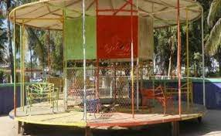
I REALLY LIKED THIS PICTURE BECAUSE IT IS ATRACTIVE IT MAY NOT BE SO LUXURIUS LIKE IN OTHER COMMON CITIES LIKE LOS MOCHIS CULICAN ETC BUT IT CAN BE VERY SPECIAL IN OUR COMUNITY BE IN OUR THOUGHTS WE DON’T NEED MUCH AS LONG AS IT THERE ALONG WITH OUR COUNTRY FLAG WE WILL ALWAYS LIKE IT AS A MEMORY THANK YOU PARQUE VILLAFAÑE FOR ALL THE MEMORIES YOU HAVE LEFT US.

