INGLES homework
The colors that this image carries are orange, yellow, black, blue and a little pink.
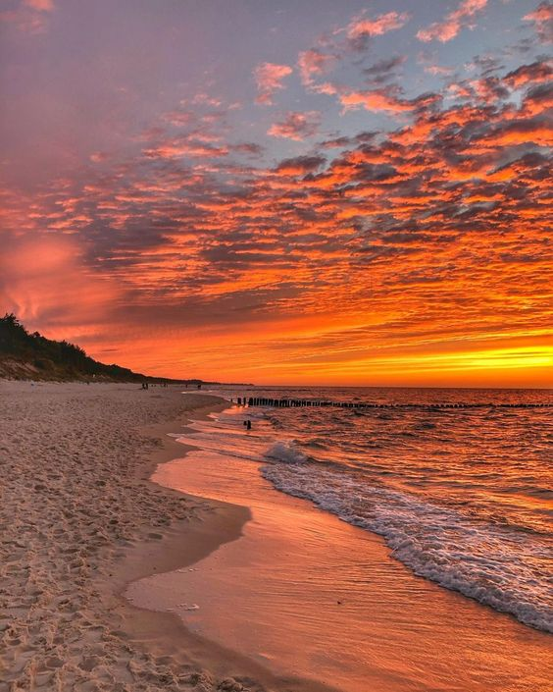
What gives me this image is peace, because I really like the beach

