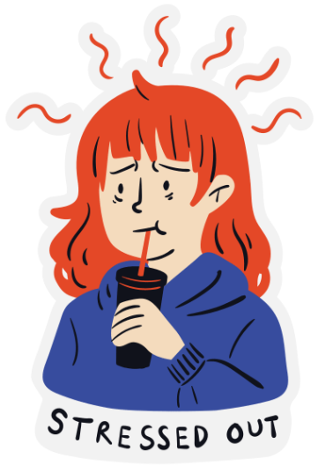
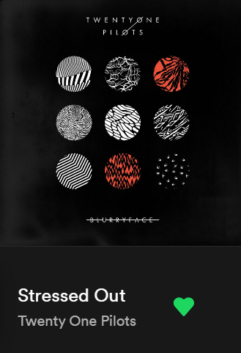

STRESS!
Stress is a really interesting and funny feeling, it is usually a response to different stimuli that have a high influence on your life, beliefs or even the way you see the world.

Stress can be defined as any action or happening that changes your current state, it can go from a single fly passing by, or failing a test, all the way to a pet dying or moving out of the city..

Did you know?

Most of the people
who suffer
stress, are teens…
But, Why?

Being a teen means being stuck between the “grow up, you are not a kid anymore” and the “hold on, you aren’t an adult yet”, so there is a lot of confusing things about being a teen, and most of the time, it manifests as stress, because of the school, your parents, your friends, your social life, etc. and not just stress, it can also manifest as depression or anxiety…

But worry not, my friend, thus it can be cured:

- Breath
  - I know this is a cliche and it may not seem like much, but breathing helps you moderate your heart rate, and by this, you can focus on managing your thoughts and going back to a calm state
- Listen to Music
  - When you have a favourite song, it means that that specific song has somehow managed to go to your subconscious and stay there… If you are feeling stressed, is very likely for you to stop thinking rationally and lose control over your thoughts and actions, so if you play your favourite song, it’ll act like a key to your subconscious, letting your mind to be free and take control back
- Listen to Soundscapes
  - Soundscapes are recordings of different environmental sounds, it can be a forest, a house, the sea, or even the shopping mall… The soundscapes work in a similar way to music, except that, your favourite song is something you discover after a few years of your life, and a soundscape is something you already have ‘by default’, so they can lead you to peaceful memories or mental images.
- Do a hobby
  - Hobbies are really useful to calm us down, they are normally used when the stress isn’t really putting you in a danger zone, in other words, they are used to distract your mind while doing something you like… This is a great option for when your stress factor isn’t really that awful.
- Mantras!
  - Mantras are a thing, a word, a sentence or even an action you do unconsciously when you want to feel better, it can either be to feel better from stress, depression or other stuff. Finding your mantra can help you find a sensitive point in your personality, like a ky point, and by repeating that mantra you memorise it, so when you feel stressed or bad, you repeat your mantra, and even when you aren’t aware you are feeling bad, it will take you back to a calm state

- Gaby Espinosa
English Advanced, October 2022

